Assignment Chapter 9 (total 25 points)

1. Write a SELECT statement that returns these columns from the Products table:

The list_price column

The discount_percent column

A column named discount_amount that uses the previous two columns to calculate the discount amount and uses the ROUND function to round the result so it has 2 decimal digits (5 points)

1. Write a SELECT statement that returns these columns from the Orders table:

The order_date column

A column that uses the DATE_FORMAT function to return the four-digit year that’s stored in the order_date column

A column that uses the DATE_FORMAT function to return the order_date column in this format: Mon-DD-YYYY. In other words, use abbreviated months and separate each date component with dashes.

A column that uses the DATE_FORMAT function to return the order_date column with only the hours and minutes on a 12-hour clock with an am/pm indicator

A column that uses the DATE_FORMAT function to return the order_date column in this format: MM/DD/YY HH:mm. In other words, use two-digit months, days, and years and separate them by slashes. Use 2-digit hours and minutes on a 24-hour clock. And use leading zeros for all date/time components. (5 points)

1. Write a SELECT statement that returns these columns from the Orders table:

The card_number column

The length of the card_number column

The last four digits of the card_number column

When you get that working right, add the columns that follow to the result set. This is more difficult because these columns require the use of functions within functions.

A column that displays the last four digits of the card_number column in this format: XXXX-XXXX-XXXX-1234. In other words, use Xs for the first 12 digits of the card number and actual numbers for the last four digits of the number.

A column that returns the third word in the product_name in the products table. If there is no third word, it should return an empty string. You can do this using IF, LOCATE, and SUBSTRING_INDEX. Hint, this is complicated, see the solution for exercise 3 in chapter 9 for some ideas.

Order by card_number. Results should be like below: (8 points)

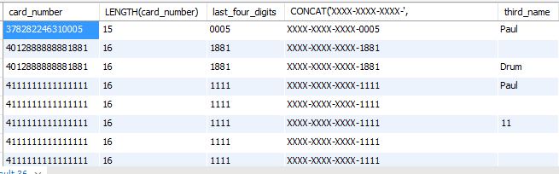

1. Write a SELECT statement that returns these columns from the Orders table:

The order_id column

The order_date column in format yyyy-mm-dd

A column named approx_ship_date that’s calculated by adding 2 days to the order_date column in format yyyy-mm-dd

The ship_date column

A column named days_to_ship that shows the number of days between the order date and the ship date

When you have this working, add a WHERE clause that retrieves just the orders for March 2015. (7 points)